**Final Project**

**Algorithm and Programming 1**

Project Name: **Pog Pong**

Name: **Avariq Fazlur Rahman**

Student ID: **2502043002**

Class: **L1CC**

**Project Specification**

This project was made to create a classic table pong-esque game that can relive some memories of playing actual table pong. This game can also serve as a very simple game that anyone can play anywhere when they are bored. This game is also a 2-player game, meaning it can be played by up to two people. The user inputs in this game goes as far as paddle movement using keyboard controls (Up and down arrow keys and W + S). These user inputs will result in the movement of the paddles. Rules of this game are like that of actual table tennis, except this game does not have a middle net. That means if one player gets the ball past the other, then they get one extra point. Because this is a casual game, there are no final scores. You and the person playing can play up to any target score that is designated.

**Input**

1. User directional movements (Player 1)
2. User directional movements (Player 2)

**Output**

1. Movement of Paddle (Player 1)
2. Movement of Paddle (Player 2)

**Solution Design**

* Main Game

**Main Game**

This is the window that shows the main game. As far as graphics go, we have two red paddles, a white ball, and a middle line. There is also the game’s title on the top left. You also have the two score counters on the bottom of each sides so you can keep track of how many points you have scored.

**Implementation and explanation of code**

Keeping up with the overall theme of this game, this game has pretty straight-forward codes. This game was made possible by using Python’s “PyGame” module. This project only consists of the one lone file that stores all of the game files. Overall, there was 122 lines that were separated into parts to make the code easier to inspect and understand as it will be per-object basis. The codes themselves looks a little bit like this :

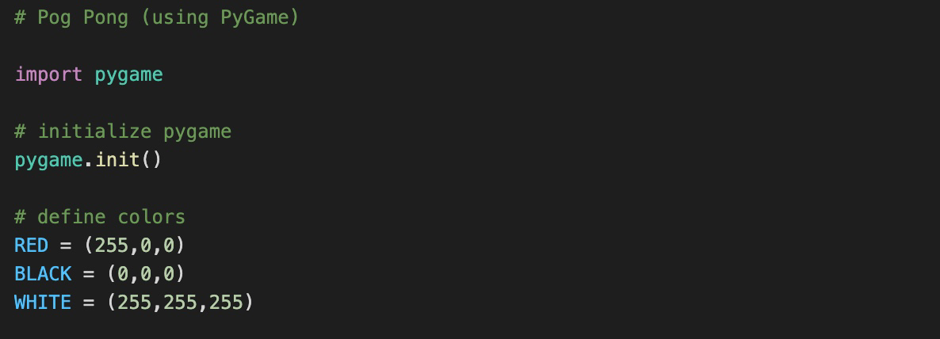

* We start the code of by activating the module PyGame by importing the module and initializing it. Next, we define the colors that will be used in this code (In this case Red, Black, and White.)



* In this part of the code, we define the size of the game on the screen, which in this instance will be 800 x 600 pixels. This, obviously, can be changed to any resolution that the player wishes to set it at.

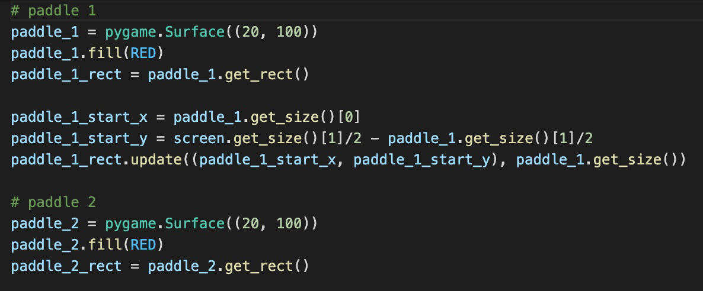

* This part of the code is to make the paddles. Here, we see the color of the paddle, the shape of the paddle, and the size of the paddle. There are 2 paddles.

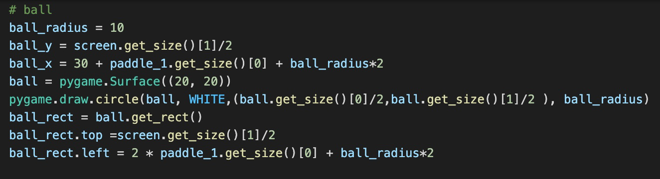

* This part of the code is the part where i made the ping pong ball. Similar to the paddle part, this determines the shape of the ball, the color of the ball, and the radius of the ball.

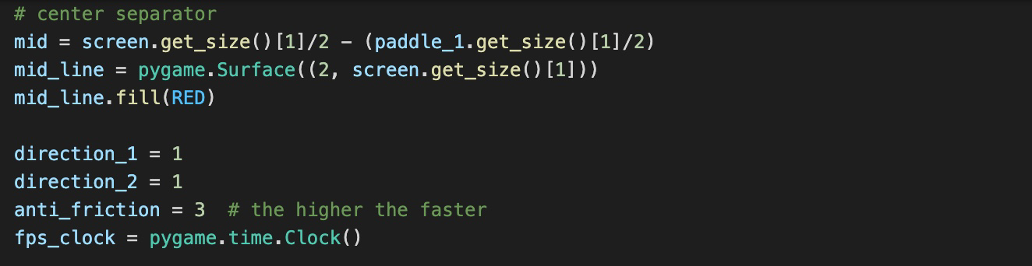

* This code houses the properties of the middle line and the player directions. For the middle line, the code tells us the size and the color. Then there are the directions for the two players, noted by 1 (and soon we will see -1 for opposite directions). Anti friction is also present as the core physics of how the ball moves (i.e having rolling contact instead of sliding contact). It also dictates how fast the ball will bounce back. And then we also have an FPS clock to monitor the frames per second.

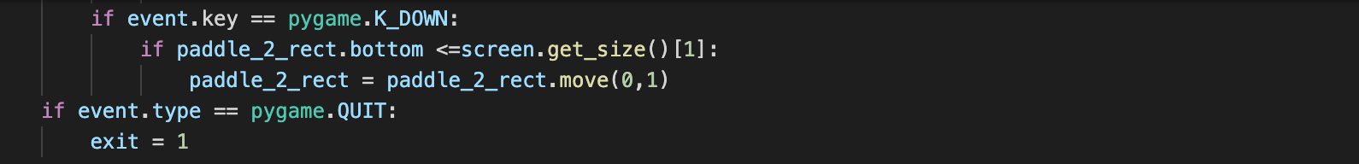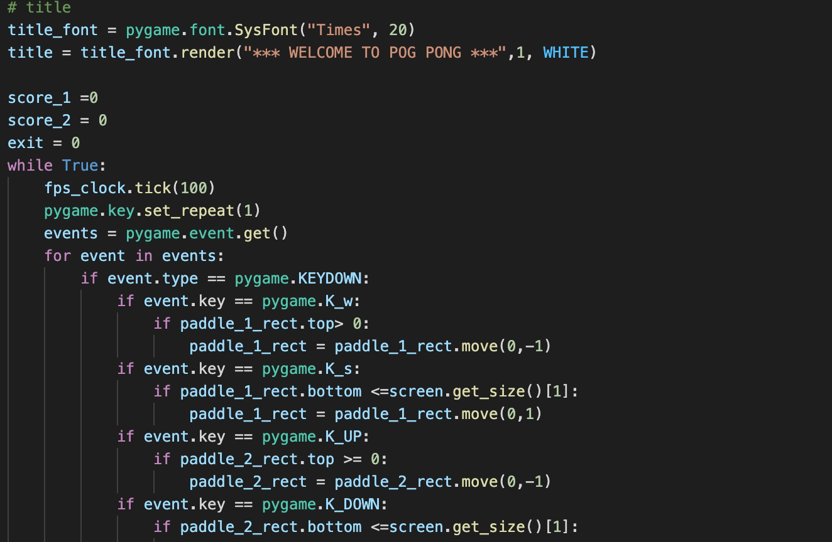

* This part of the code houses the main things that we will use in the game, mainly title, base score, and movements. For the title we have the font and the placement, and the color of the font. Then below that we have the base that we will use for the scores moving forward and the exit. Below that is where we see how the game works in terms of movements. We use W, S, UP, and DOWN to move the paddles. We also see what happens if we quit the game which exits the game.

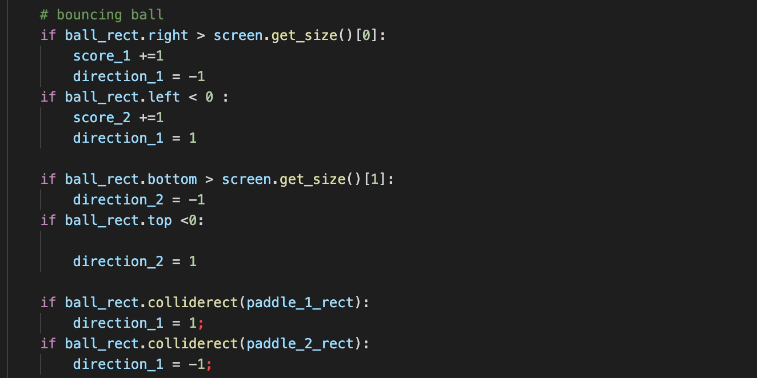

* This part of the code houses the physics of the ping pong ball and how a player gets their points. This also houses the behavior of what the ball will do if it hits the paddles.

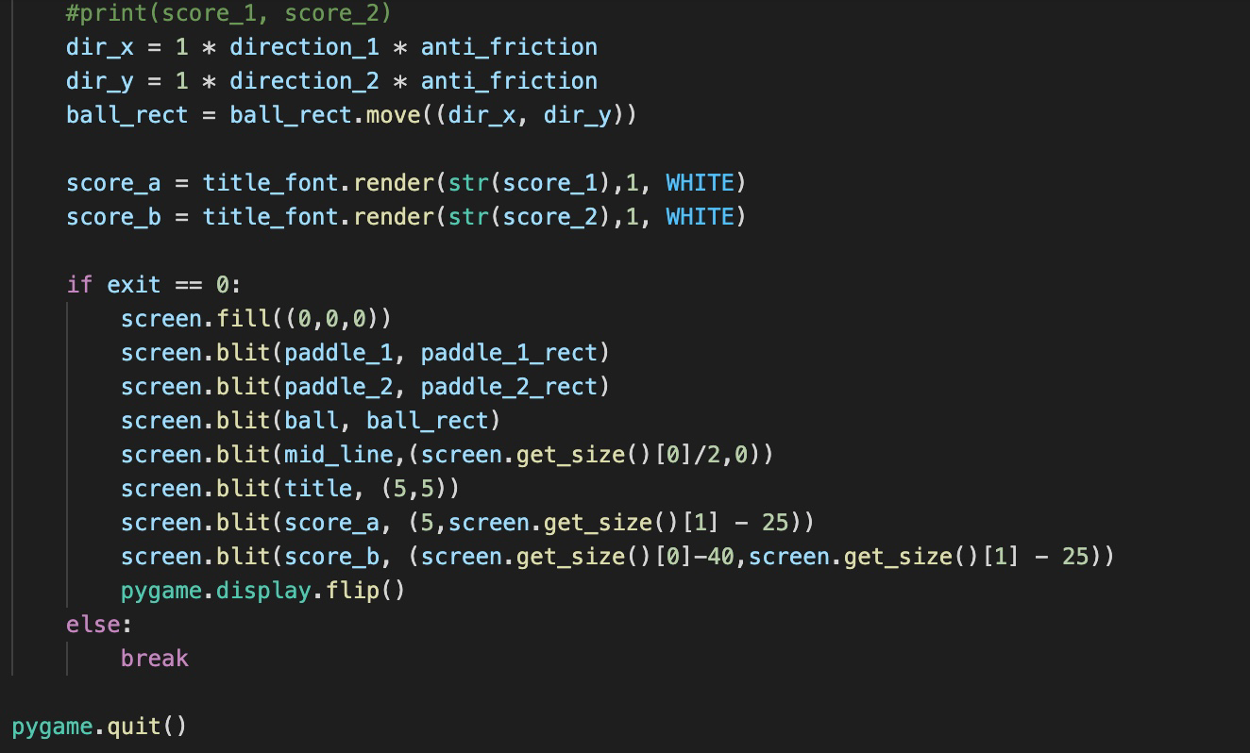

* This is the ending part of the code and what this part is essentially about is printing the scores. It also houses what happens when the player exits the game.

**FINISHED PRODUCT**

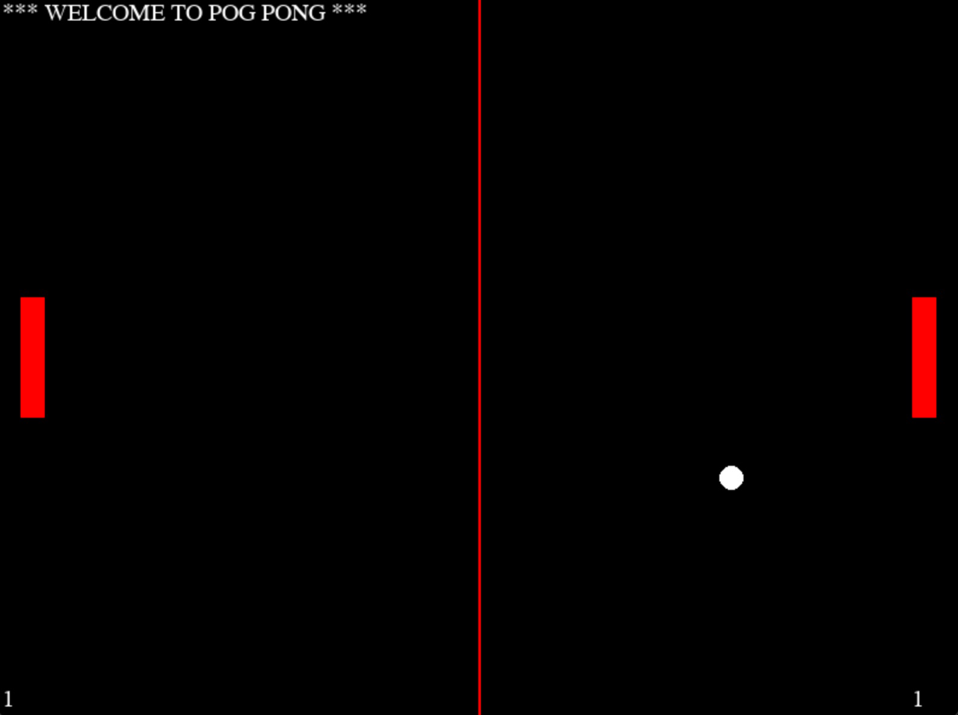As the above section of this report stated the codes that were used, this was the end result of all of those codes above.